Conjectures:
⇒ (implies)
e.g. x = 4 ⇒ x² = 16

⇔ (equivalent)
e.g. x= ±4 ⇔ x²= 16

Quantifiers:
:(For all)
: ( real set)
Z: (integer set)
∈: (element)

∃ : (there exists)
e.g. ∃x∈Z

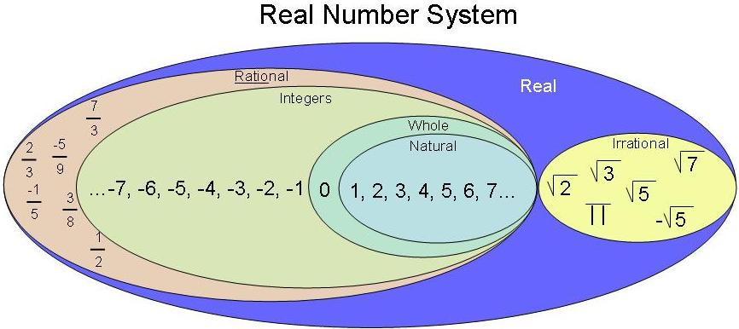

Implications: ⇒ one way
Equivalence: ⇔ two-way

Converse:
** Works for most definitions
P⇒Q
Converse is Q⇒P
Is when the hypothesis and conclusion of a statement is switched. However, the converse of a true statement need not be true
e.g. if x=2 then x²=4 is true
if x² = 4 is false (because x could be -2)

Although if the statement are true they are equivalent statements can be written ‘ P if only Q’
e.g. A triangle has two sides of the same length if and only if it has two angles in size.

Contrapositive:
P⇒Q
The contrapositive is “If not Q then not P”
Is when the hypothesis and the conclusion of a conditional statement is switches and then negating both.
e.g. if x=2 then x² then x²=4
Contrapositive statement: if x² ≠4 then x ≠2

The contrapositive of a true statement is also true
e.g. if a polygon has exactly 4 sides then the polygon is a quadrilateral (True statement)
If a polygon is not a quadrilateral then it does not have exactly four sides (The contrapositive is also true)

Inverse:
P⇒Q
The inverse statement is: if not P then not Q
Negating both the hypothesis and the conclusion of a conditional statement.

Negation: (not)
If P is the statement
It is raining
Then the negation of P is the statement:
It is not raining

Assume the opposite and prove the opposite wrong

e.g. the statement:
You cannot have a right-angle triangle with one side of length 3x cm, another side length (4x+5) cm and the longest side of length (5x+4)
Assume the opposite
Assume that we can indeed have a right-angle triangle with the given side lengths and the prove that this assumption leads to something that cannot be true.

Pigeon-Hole Principles:
If there are n pigeon holes, n 1, and n+1 pigeons go in them, then at least one pigeon hole must get two or more pigeons.
e.g. a letterman has 7 letters, but there’s only 6 letter boxes. Therefore, one of the letter boxes will have at least 2 letters.

Concluding
Thus for this statement if P then Q
The converse statement is if Q then P
The contrapositive is if not Q then not P
The inverse statement is if not P then not Q

- The contrapositive statement involves both the effect of the converse, in its switch of P and Q, and the inverse, with its negations of both P and Q
- If the original statement is true then the contrapositive is also true but the converse and the inverse may not be

